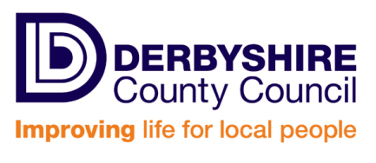
INSTRUMENT OF GOVERNMENT – COMMUNITY SCHOOL

(1) The name of the school is Holmesdale Infant School.
(2) The school is a Community school.
(3) The name of the governing body is "The governing body of Holmesdale Infant School”.
(4) The governing body shall consist of:-
a. 3 parent governors.
b. 1 LA governor.
c. 1 staff governor.
d. 1 Headteacher.
e. 3 co-opted governors.
(5) Total number of governors is 9.
(6) The term of office of all governors is 4 years.
(7) This Instrument of Government comes into effect on the day of making, replacing the Instrument of Government made on 10 May 2011.
(8) This Instrument was made by order of Derbyshire Local Authority on 16 June 2015.
(9) A copy of the Instrument of Government must be supplied to every member of the governing body (and the Headteacher if not a governor).

